FMCIA – Create Commitment Item

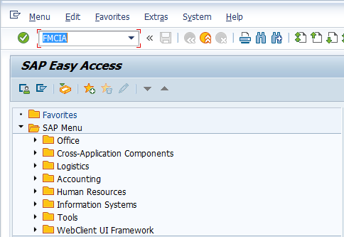

- Input FMCIA in Transaction Box and press Enter key

Enter FM Area Screen.

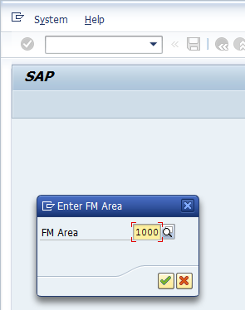

- FM Area: Input or select FM area with the help of F4 key
Press Enter key

Edit Commitment Item Screen.

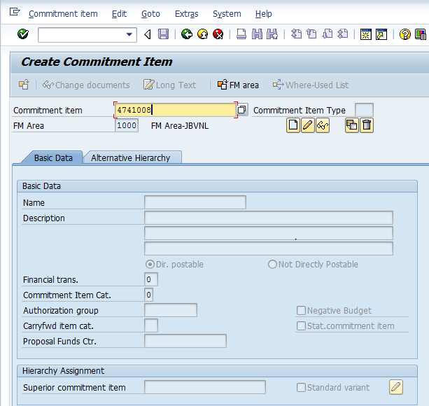

- Commitment Item: Input commitment item to be created
Click on Create icon

Create Commitment Item Screen.

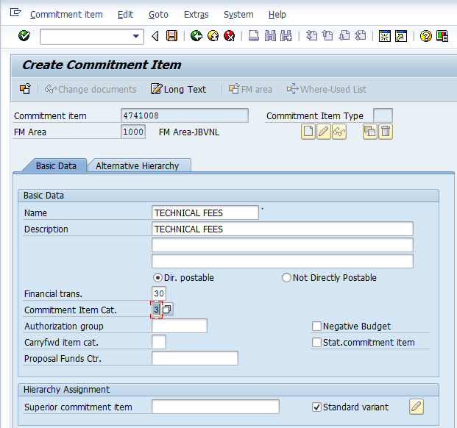

- Name: Input short name of commitment item
- Description: Input description of the commitment item

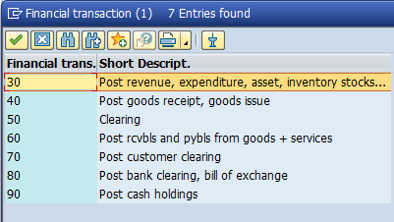

- Financial trans.: Select relevent financial transaction code from the above list
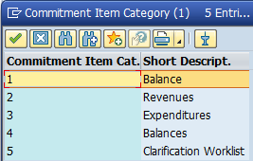

- Commitment Item Cat.: Select relevant item category from the above list
Click on Save icon or press Ctrl+S keys to save the data.

The Commitment saved successfully message appears at bottom of the screen

Manual End

